Santa Maria Style BBQ
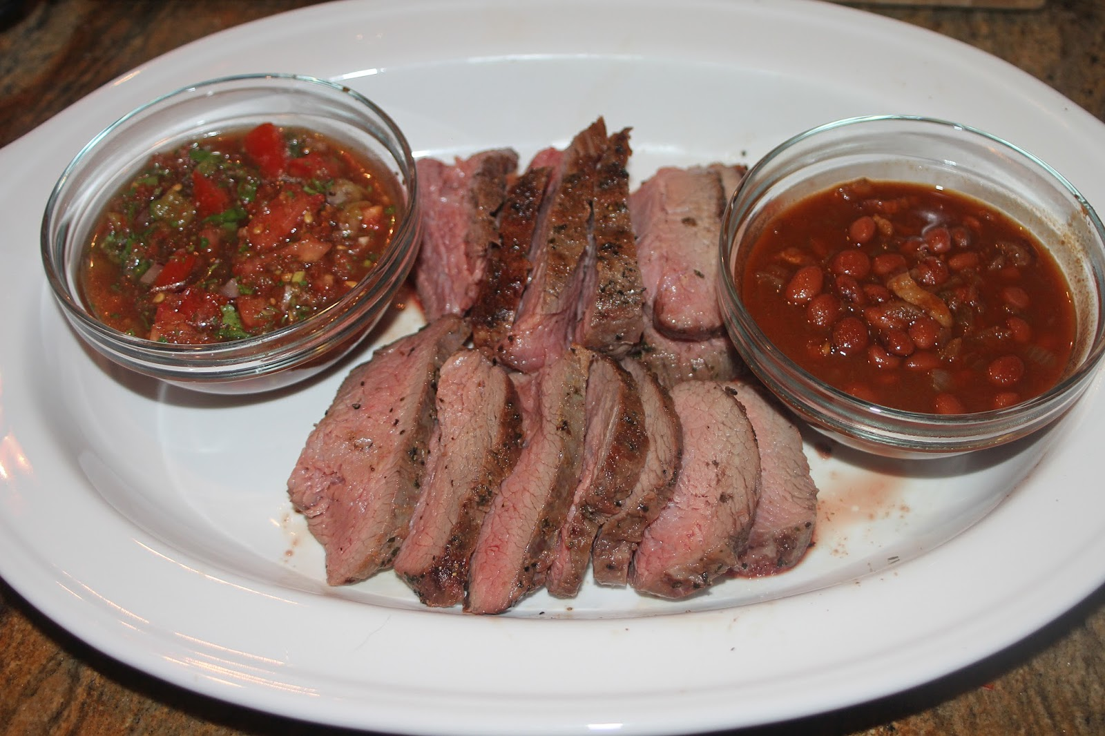

Package # 1
$ 52 Per person
$ 15 per kids under 10
Buffet Style

$56 per person
$15 per kids under 10
Platted meals

- Three Entrees
* Santa Maria Grilled Tri-Tip Beef
* Baby Back Pork Ribs
* Grilled Chicken ¼
* New York steak
* Rib eye steak
* Salmon
* Sirloin Steak
* Ham

* Four Sides
* Gourmet lettuce mix green salad with mango, strawberries, dried cranberries, candied walnuts, crumbled with Italian dressing or homemade ranch
* Caesar Salad with homemade ranch
* Italian Pasta Salad
* Black Bean and Corn, Avocado, Salad
* Perruano Beans
* Chili Beans
* Alfredo Pasta
* Spanish rice
* Pilaf rice
* Scalloped potatoes
* Green bean casserole
* Mash potatoes
* Potato salad
* Macaroni salad
* Grilled Asparagus
* Garlic-Parm Zucchini Saute
* Roasted Corn
* Sauteed Brussels Sprouts
* Steam vegetables
* Garlic bread or Dinner rolls

Drinks
You can Choose Two Drinks
* Mix cans sodas
* Lemonade
* Coffee
* Tea
* Bottle of water
* Aguas Frescas:
Horchata, Tamarindo, Jamaica, Pineapple, Melon, Mango, Orange, Watermelon, Strawberry, Cucumber with Lime, Horchata with Melon,

* Misc
* Glass plates, cups, Silverware, your choice of cloth napkigs

Package # 2
$36 Per person
$15 per kids under 10
Buffet Style

$40 per person
$15 per kids under 10
Platted Meals

- Two Entrees Your choice

* Santa Maria Grilled Tri-Tip Beef
* Baby Back Pork Ribs
* Grilled Chicken ¼
* New York steak
* Salmon
* Ham

* Four Sides

* Gourmet lettuce mix green salad with mango, strawberries, dried cranberries, candied walnuts, crumbled with Italian dressing or homemade ranch
* Caesar Salad with homemade ranch
* Italian Pasta Salad
* Perruano Beans
* Chili Beans
* Alfredo Pasta
* Spanish rice
* Pilaf rice
* Scalloped potatoes
* Green bean casserole
* Mash potatoes
* Potato salad
* Macaroni salad
* Grilled Asparagus
* Garlic-Parm Zucchini Saute
* Roasted Corn
* Sauteed Brussels Sprouts
* Steam vegetables
* Garlic bread or Dinner rolls

Drinks
* Mix cans sodas
* Lemonade
* Coffee
* Tea
* Bottle of water
* Aguas Frescas:
Horchata, Tamarindo, Jamaica, Pineapple, Melon, Mango, Orange, Watermelon, Strawberry, Cucumber with Lime, Horchata with Melon,

* Misc
* Glass plates, Glass cups, Silverware, your choice of cloth napkings

Package # 3
$28 per person
$12 per kids under 10
Buffet Style

$32 per person
$12 per kids under 10
Platted Meals

- One Entrees your choice
* Santa Maria Grilled Tri -Tip Beef
* Baby Back Pork Ribs
* Grilled Chicken ¼
* Salmon
* Ham

* Three Sides
* Gourmet lettuce mix green salad with mango, strawberries, dried cranberries, candied walnuts, crumbled with Italian dressing or homemade ranch
* Caesar Salad with homemade ranch
* Italian Pasta Salad
* Black Beans, corn, bell-pepper, cilantro, and Avocado, Salad
* Perruano Beans
* Chili Beans
* Alfredo Pasta
* Spanish rice
* Pilaf rice
* Scalloped potatoes
* Green bean casserole
* Mash potatoes
* Potato salad
* Macaroni salad
* Grilled Asparagus
* Garlic-Parm Zucchini Saute
* Roasted Corn
* Sauteed Brussels Sprouts
* Steam vegetables
* Garlic bread or Dinner rolls

Drinks
* Mix cans sodas
* Lemonade
* Coffee
* Tea
* Bottle of water
* Aguas Frescas:
Horchata, Tamarindo, Jamaica, Pineapple, Melon, Mango, Orange, Watermelon, Strawberry, Cucumber with Lime, Horchata with Melon,

* Misc
* Glass plates, Glass cups, Silverware, your choice of cloth color (napkings)

Tacos:
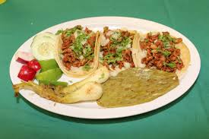

Packege #1

$26 per person all you can eat
$12 per kids under 10
Buffet Style

* Three kinds of meat your choice *
* Asada
* Pastor
* Chicken
* Chicken fajitas
* Chorizo
* Carnitas
* Shrimp fajitas
* Chicharon with Chile
* Mix Vegetable (Garbanzo, Corn, Black beans, red, orange and green bell pepper, onions,)
* Birria
* Quesabirria

Serve with Spanish Rice and Beans
Fixing Side
* Cilantro
* Onions
* Limes
* Cucumber
* Radish
* Cabbage
* Two Salsa

Drinks
* Mix cans sodas
* Lemonade
* Coffee
* Tea
* Bottle of water
* Aguas Frescas:
Horchata, Tamarindo, Jamaica, Pineapple, Melon, Mango, Orange, Watermelon, Strawberry, Cucumber with Lime, Horchata with Melon,

* Misc
* Glass plates, cups, Silverware, your choice of cloth napkings

Packege #2

$24 per person all you can eat
$12 per kids under 10

* Three kinds of meat your choice *
* Asada
* Pastor
* Chicken
* Chicken fajitas
* Chorizo
* Carnitas
* Shrimp fajitas
* Chicharon with Chile
* Mix Vegetable (Garbanzo, Corn, Black beans, red, orange and green bell pepper, onions,)
* Birria
* Quesabirria

Fixing Side
* Cilantro
* Onions
* Limes
* Cucumber
* Radish
* Cabbage
* Green and Red Salsa

Drinks
* Mix cans sodas
* Lemonade
* Coffee
* Tea
* Bottle of water

* Aguas Frescas:
Horchata, Tamarindo, Jamaica, Pineapple, Melon, Mango, Orange, Watermelon, Strawberry, Cucumber with Lime, Horchata with Melon,

* Misc
* Glass plates, Glass cups, Silverware, your choice of cloth napkings

Italian:
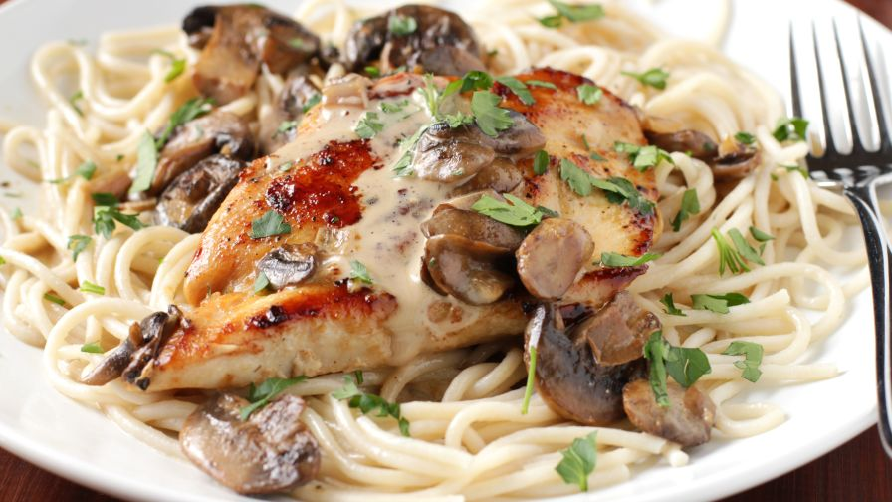

Package#1

$ 26 per person
$ 12 per Kids under 10
one Entree

* Grilled Chicken
* Shrimp
* Served with Fettuccine Alfredo pasta,
* Gourmet lettuce mix green salad with mango, strawberries, dried cranberries, candied walnuts, crumbled with Italian dressing or homemade ranch.
* Garlic bread or Dinner rolls

*Spaghetti meat balls.
* Gourmet lettuce mix green salad with mango, strawberries, dried cranberries, candied walnuts, crumbled with Italian dressing or homemade ranch.
* Garlic bread or Dinner rolls

Drinks
* Mix cans sodas
* Lemonade
* Coffee
* Tea
* Bottle of water
* Aguas Frescas:
Horchata, Tamarindo, Jamaica, Pineapple, Melon, Mango, Orange, Watermelon, Strawberry, Cucumber with Lime, Horchata with Melon,

* Misc
* Glass plates, Glass cups, Silverware, your choice of cloth napkings

2

Fajitas

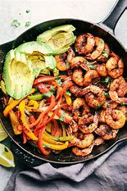

$ 26 per person
$ 12per kids under 10

- Shirm Fajitas
- Asada Fajitas
- Chicken Fajitas
- Combined with Spanish rice and beans

*Drinks
* Mix cans sodas
* Lemonade
* Coffee
* Tea
* Bottle of water

* Aguas Frescas:
Horchata, Tamarindo, Jamaica, Pineapple, Melon, Mango, Orange, Watermelon, Strawberry, Cucumber with Lime, Horchata with Melon,

* Misc
* Glass plates, Glass cups, Silverware, your choice of cloth napkings

Carnitas

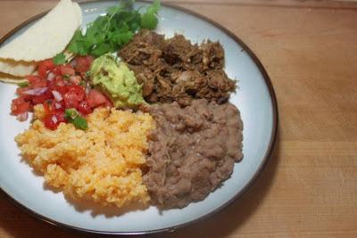

$ 26 per person
$ 12 per kids under 10

* Serve with
* Pinto beans
* Spanish Rice
* Pico de gallo
* Cactus salad
* Salsa
* Guacamole
* Tortillas

Drinks
* Mix cans sodas
* Lemonade
* Coffee
* Tea
* Bottle of water

* Aguas Frescas:
Horchata, Tamarindo, Jamaica, Pineapple, Melon, Mango, Orange, Watermelon, Strawberry, Cucumber with Lime, Horchata with Melon,

* Misc
* Glass plates, Glass cups, Silverware, your choice of cloth napkings

Birria

Package #1
$24 Per person
$12 Per Kids under 10

Beef Birria
* Spanish Rice
* Beans
* Tortillas
* Salsa
* Limes
* Cilantro
* Onions

Mexican Buffet
$ 52 per person

Qty of 8 item
Serve with salsa, sour cream and tortillas.

* Birria
* Quesabirria
* Shrimp Cocktail
* Aguachiles (shrimp cooked with lime juice)
* Enchiladas en el orno ( chicken, cheese, beef).
* Costillas de puerco con chile / Spare ribs in red or green sause.
* Tacos (Asada, Alpastor, Chorizo, Chicken, Carnitas and chicharon with chile).
* Fajitas ( chicken, beef, and shrimp).
* Chicharon con chile / pork skin with red or green sause.
* Carnitas
* Chile rellenos de queso
* Pico de gallo with cactus.
* Guacamole dip
* Spanish rice
* Pinto beans. Chili beans or re-fried beans
*

Drinks
* Mix cans sodas
* Lemonade
* Coffee
* Tea
* Bottle of water

* Aguas Frescas:
Horchata, Tamarindo, Jamaica, Pineapple, Melon, Mango, Orange, Watermelon, Strawberry, Cucumber with Lime, Horchata with Melon,

* Misc
* Glass plates, Glass cups, Silverware, your choice of cloth napkings

Appetizers:

* Bacon Wrapped Jalapeno Peppers. $6.00 per person

* Chips, salsa and Guacamole . $6.00 per person

* Chicken or Cheese Quesadilla $5.00 per person

* Carnita Sliders. $9.00 per person

* Tri tip sliders. $10.00 per person

* Shrimp Cocktail. $10.00 per person

* Charcuterie Board $15.00 per person

* Meat Balls $6.00 per person

* Linguica $5.00 per person

All you can eat for 1-2 Hrs.

Additional UN-contracted Services

Cake Services $285 Bussing Services Setting or Breaking Chairs and Tables
plates, spoons, napkings
50-150 Guests $250 $375
150-250 Guests $ 325
250 Guests and up 425

